**SEO Title:** Ibogaine Mesodosing Week 2: Reclaiming Agency with Ibotincture TA

**Meta description:** Week 2 of my ibogaine mesodosing journey: Ibotincture TA, alcohol cravings, burnout and small daily wins in sobriety, creativity and self-care.  
  
Slug: ibogaine-mesodosing-week-2-reclaiming-agency-with-ibotincture-ta

**Keywords and Keyphrases:**   
ibogaine mesodosing, ibogaine mesodosing journey, mesodosing with ibogaine, ibogaine mesodosing journal, mesodosing journal, ibogaine mesodosing for alcohol cravings, ibogaine mesodosing for depression and anxiety, ibogaine mesodosing for creative flow, ibogaine microdosing for addiction recovery, ibogaine treatment integration, plant medicine integration for burnout, ibogaine mesodosing protocol, gentle ibogaine mesodosing protocol, Ibotincture TA, Ibotincture, ibogaine mesodosing tincture, ibogaine mesodosing Week 1, Mesodose, Ibogenics, Tabula Rasa Retreat, psychedelic integration and addiction counselling, psychedelic integration counsellor, psychedelic plant medicines, ibogaine treatment, ayahuasca, psilocybin mushrooms, 5-MeO-DMT, executive burnout, burnout, addiction recovery, alcohol cravings, relapse, sobriety, recovery journey, depression, anxiety, apathy of depression, self-soothing patterns, self-care, creative flow, creativity, writer, journaling, breathwork, meditation, nature, sunrise, river walks, psoriasis, ADHD, boundaries, nervous system regulation, emotional regulation, dissociation, porn (as coping), integration work, inner work, trauma response

**Main Photo:   
  
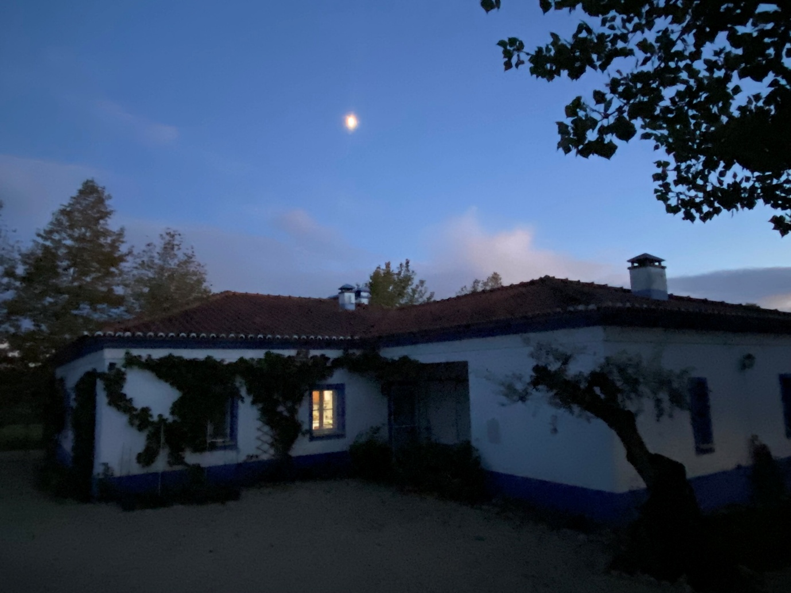**

**Ibogaine Mesodosing Week 2: Reclaiming Agency with Ibotincture TA**

**11111. Introduction**

If you read my Ibogaine Mesodosing Week 1 [LINK_TO_WEEK_1_BLOG] journal, you might be wondering why I had hit the rough patch I was trying to crawl out from in my **ibogaine mesodosing** journey.

I won’t go into to too much detail over it, as some things are too personal for me to share, but I can say that some of it involved family, and another part involved a deep need for processing time.

From October 2022 to July 2024 I worked at [Tabula Rasa Retreat](https://www.tabularasaretreat.com/) in **psychedelic integration and addiction counselling.**

In that time, I also underwent a full **ibogaine treatment integration** process ([read about it here](https://www.tabularasaretreat.com/ibogaine-rewires-the-brain/),) and I also had two full sessions of ayahuasca, two full sessions of psilocybin mushrooms, and 5-MeO-DMT.

It is [the nature of psychedelic plant medicines](https://www.tabularasaretreat.com/the-role-of-ibogaine-and-psychedelics-in-addressing-intergenerational-trauma/) that they bring up the dregs of all you have ever been suppressing since childhood, and this was no different.

As I was healing and doing my own inner work, I was also helping others heal and do theirs, taking what I was learning on the ground, and sharing what had worked for me since quitting heroin in 2015, and what I was now newly discovering about the nature of addiction.

Over the nearly two years of working as a psychedelic integration and addiction counsellor on the ground, spending 5 days a week at Tabula Rasa Retreat, and coming up to Lisbon in the weekends, I eventually hit a wall in my **healing journey**. Not only in my own healing, but I was also exhibiting all the [symptoms of executive burnout](symptoms%20of%20executive%20burnout).

It showed up first as a kind of emotional bankruptcy. By the time I got to the end of each day, there was nothing left in the tank. I wasn’t just tired, I felt used up.

Weekends stopped being restorative and turned into brief pauses in a kind of ongoing fatigue that never really lifted.

I started to doubt my judgement with clients, with colleagues, with myself. The more “responsible” I tried to be, the more I felt like an imposter in my own life, a person who looked competent on the outside but internally was constantly second-guessing, quietly convinced that sooner or later everyone would see I didn’t really know what I was doing.

My body had its own way of confirming the story. Sleep became fractured and unreliable; I would lie awake at night with my heart racing or wake up already tense and depleted.

I pulled back from people, cancelled plans, worked later, skipped breaks, and pushed through when I should have stopped.

On the surface I was still “showing up,” but inside I was disappearing: into brain fog, into overwork, into that quiet, lonely place where you’re present for everyone else’s crises and can’t quite admit you’re in the middle of your own.

There came a point where I had to admit: I was overwhelmed, and needed to take a break to process everything that was coming up for me in my own psychedelic healing journey.

At the end of July 2024, I took an indefinite break to work on myself.

When I next felt ready to work with [Alvaro](https://mesodose.com/mesostory) and Tabula Rasa Retreat, the opportunity came to launch two other side projects with him: [Mesodose](https://mesodose.com/) and [Ibogenics](https://ibogenics.com/) both centred around **mesodosing with ibogaine** and ibogaine extraction rather than high-dose interventions.

Except this time around, I would choose to be on the brainstorming and writing side only, helping build the brands and get them up and running, as I felt I still needed to resolve a few internal issues before feeling ready to work with clients one-on-one again.

I hope you enjoy Week Two of this **mesodosing journal!**

**22222. Thursday 15th May – Mesodosing Day 10**

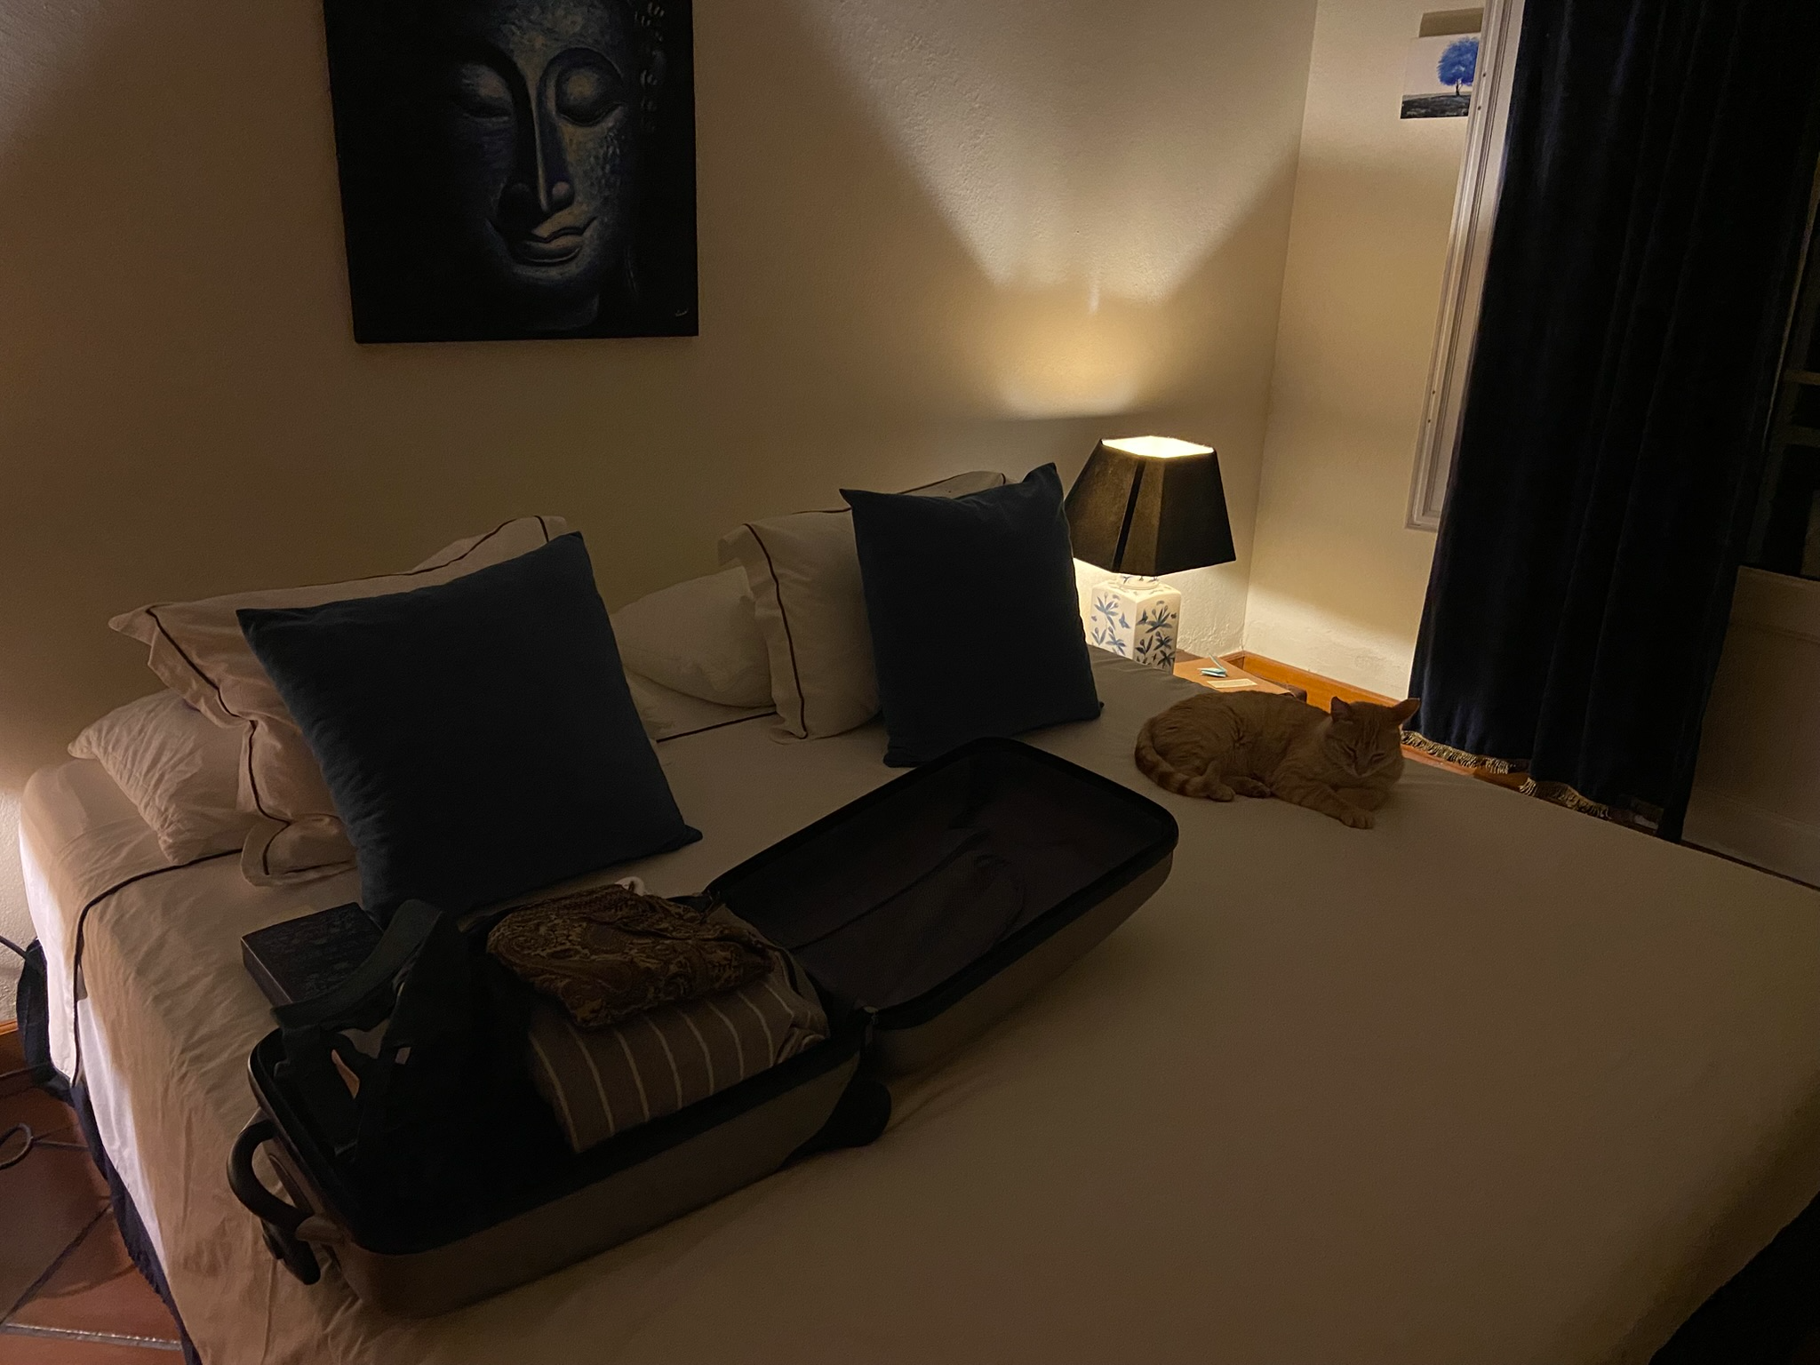

**Ibotincture drops – Did not dose**

* I will meet this place with gratitude and let it remind me who I am becoming.
* How will I pace myself today so rest and simplicity feel like choices, not guilt?
* What small way will I honour creativity without forcing output?

Tue 13 – 15 drops → Day 8  
Wed – Did not dose→ Day 9

To be down at [Tabula Rasa Retreat](https://www.tabularasaretreat.com/join-the-trr-family/your-stay/), in the very room where I first underwent an ibogaine treatment is a blessing — I hadn’t enjoyed this place fully as a guest in 2½ years, and so much has changed!

So grateful to Alvaro allowed my two best friends and I to come down here for a few days’ rest on a week where no treatments were booked. How wonderful to have lunch with some of my old colleagues!

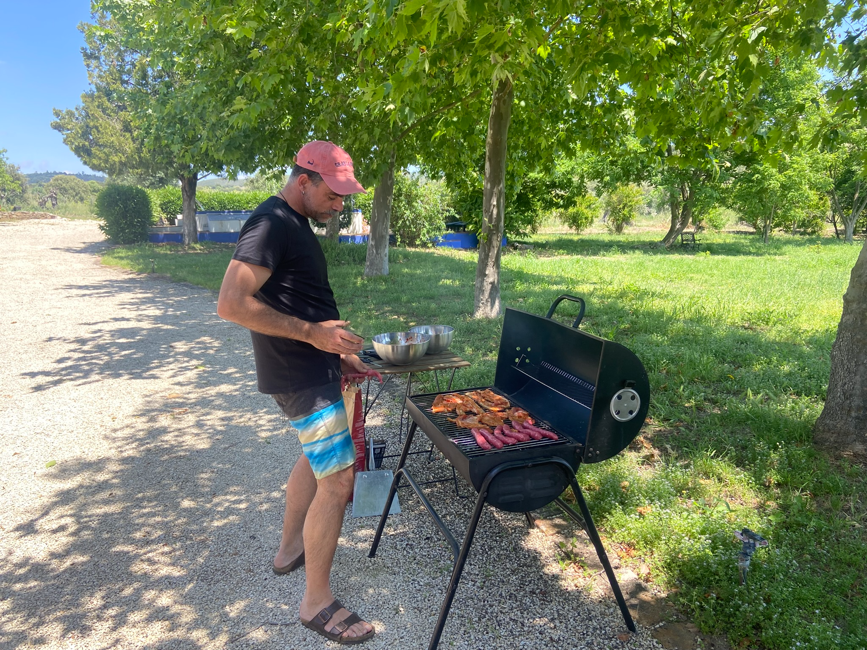

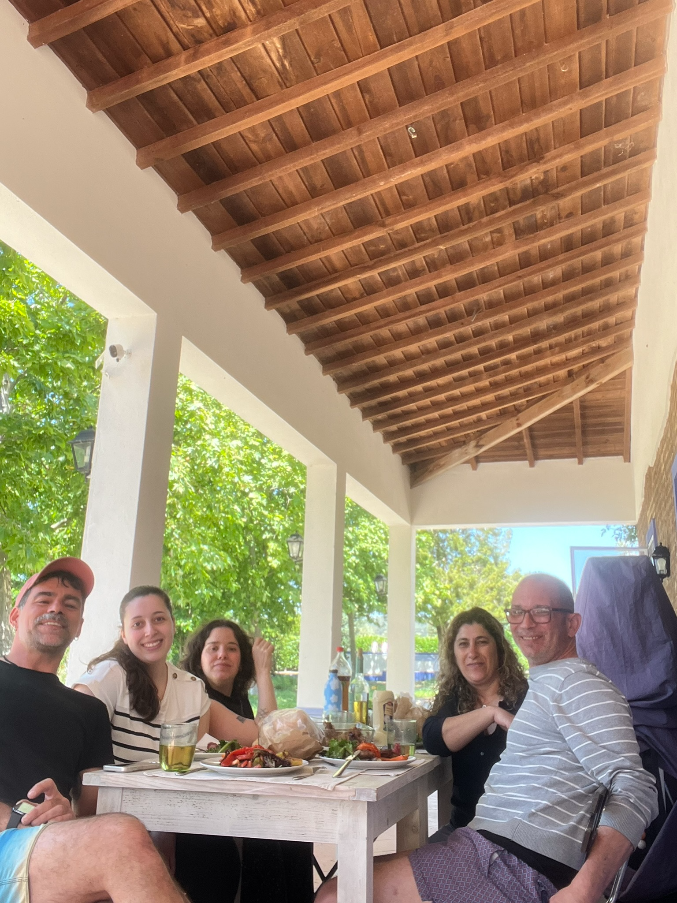

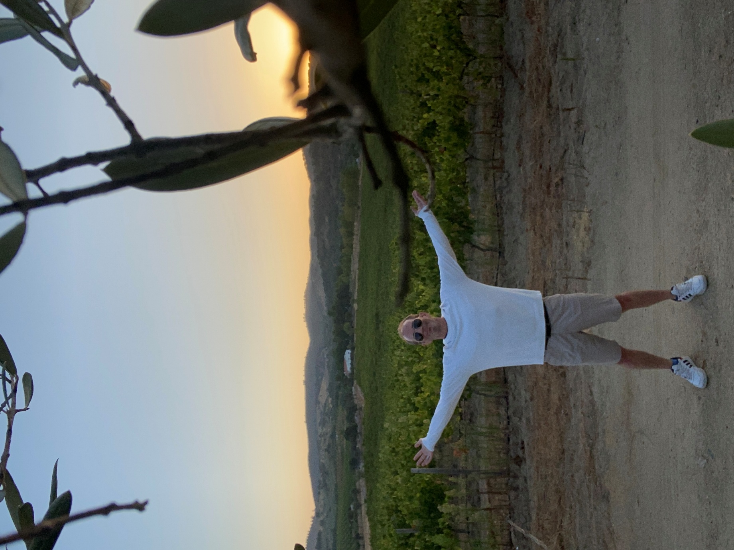

**33333. Friday 16th May — Mesodosing Day 11**

**Ibotincture drops – Did not dose**

* ***How will I listen more than I speak and let friendship mirror me kindly?***
* ***I will allow rest without earning it and soften shame when it appears.***
* ***What practice will help me choose gentleness over performance today?***

A few weeks ago, C_____ and M______ had a sit-down chat with me about my drinking relapse.

Last night, sitting out under the starry sky of the Alentejo night, I thanked them for that conversation.

They said that it was mainly about why I drink…to escape things.

Also about who I become when I’m drunk: someone who takes up all the air in a room.

However, ever since then, I have been allowing them the space to talk, exist, play their own music instead of me always stealing the show.

I realize now that I have always done that: talked over people, imposed my music, my films, etc without ever really allowing others space to be themselves.

Possibly as an inherited trauma response from my mother “wound” plus as a result of my bullying.

During my childhood, my mother’s chronic depression made me learn that I needed extreme states of emotion to be noticed by her.

My bullying, instead of making me erase myself, turned me into the “entertainer,” the class joker and storyteller as a way to not get beaten up and be respected. If I made them laugh with me, they wouldn’t hit me.

Also, the guilt and shame I carry over not performing.

**Intention for today:** To be gentle with myself and allow myself a day of rest and no work with no guilt or shame.

**44444. Saturday 17th May — Day 12**

**10:45 am —** 30 drops of [Ibotincture TA](https://mesodose.com/products/0), my current **ibogaine meso dosing** tincture.

* ***I will greet sunrise as teacher and let nature re-tune my attention.***
* ***How will I create for joy today rather than for proof?***
* ***What boundary will keep my energy steady while I explore?***

Woke up at 5:30am to watch the sunrise from the rocks at the top of the hill.

Sitting here with panoramic view over the valley.

Was only going to take the tincture again on Monday, but decided to take a 30-drop Ibotincture booster, a kind of ibogaine mesodosing for creative flow, to connect me to nature and my own creativity.

Am going to spend day taking experimental shots and videos for the website. Also plan to finish final version of texts.

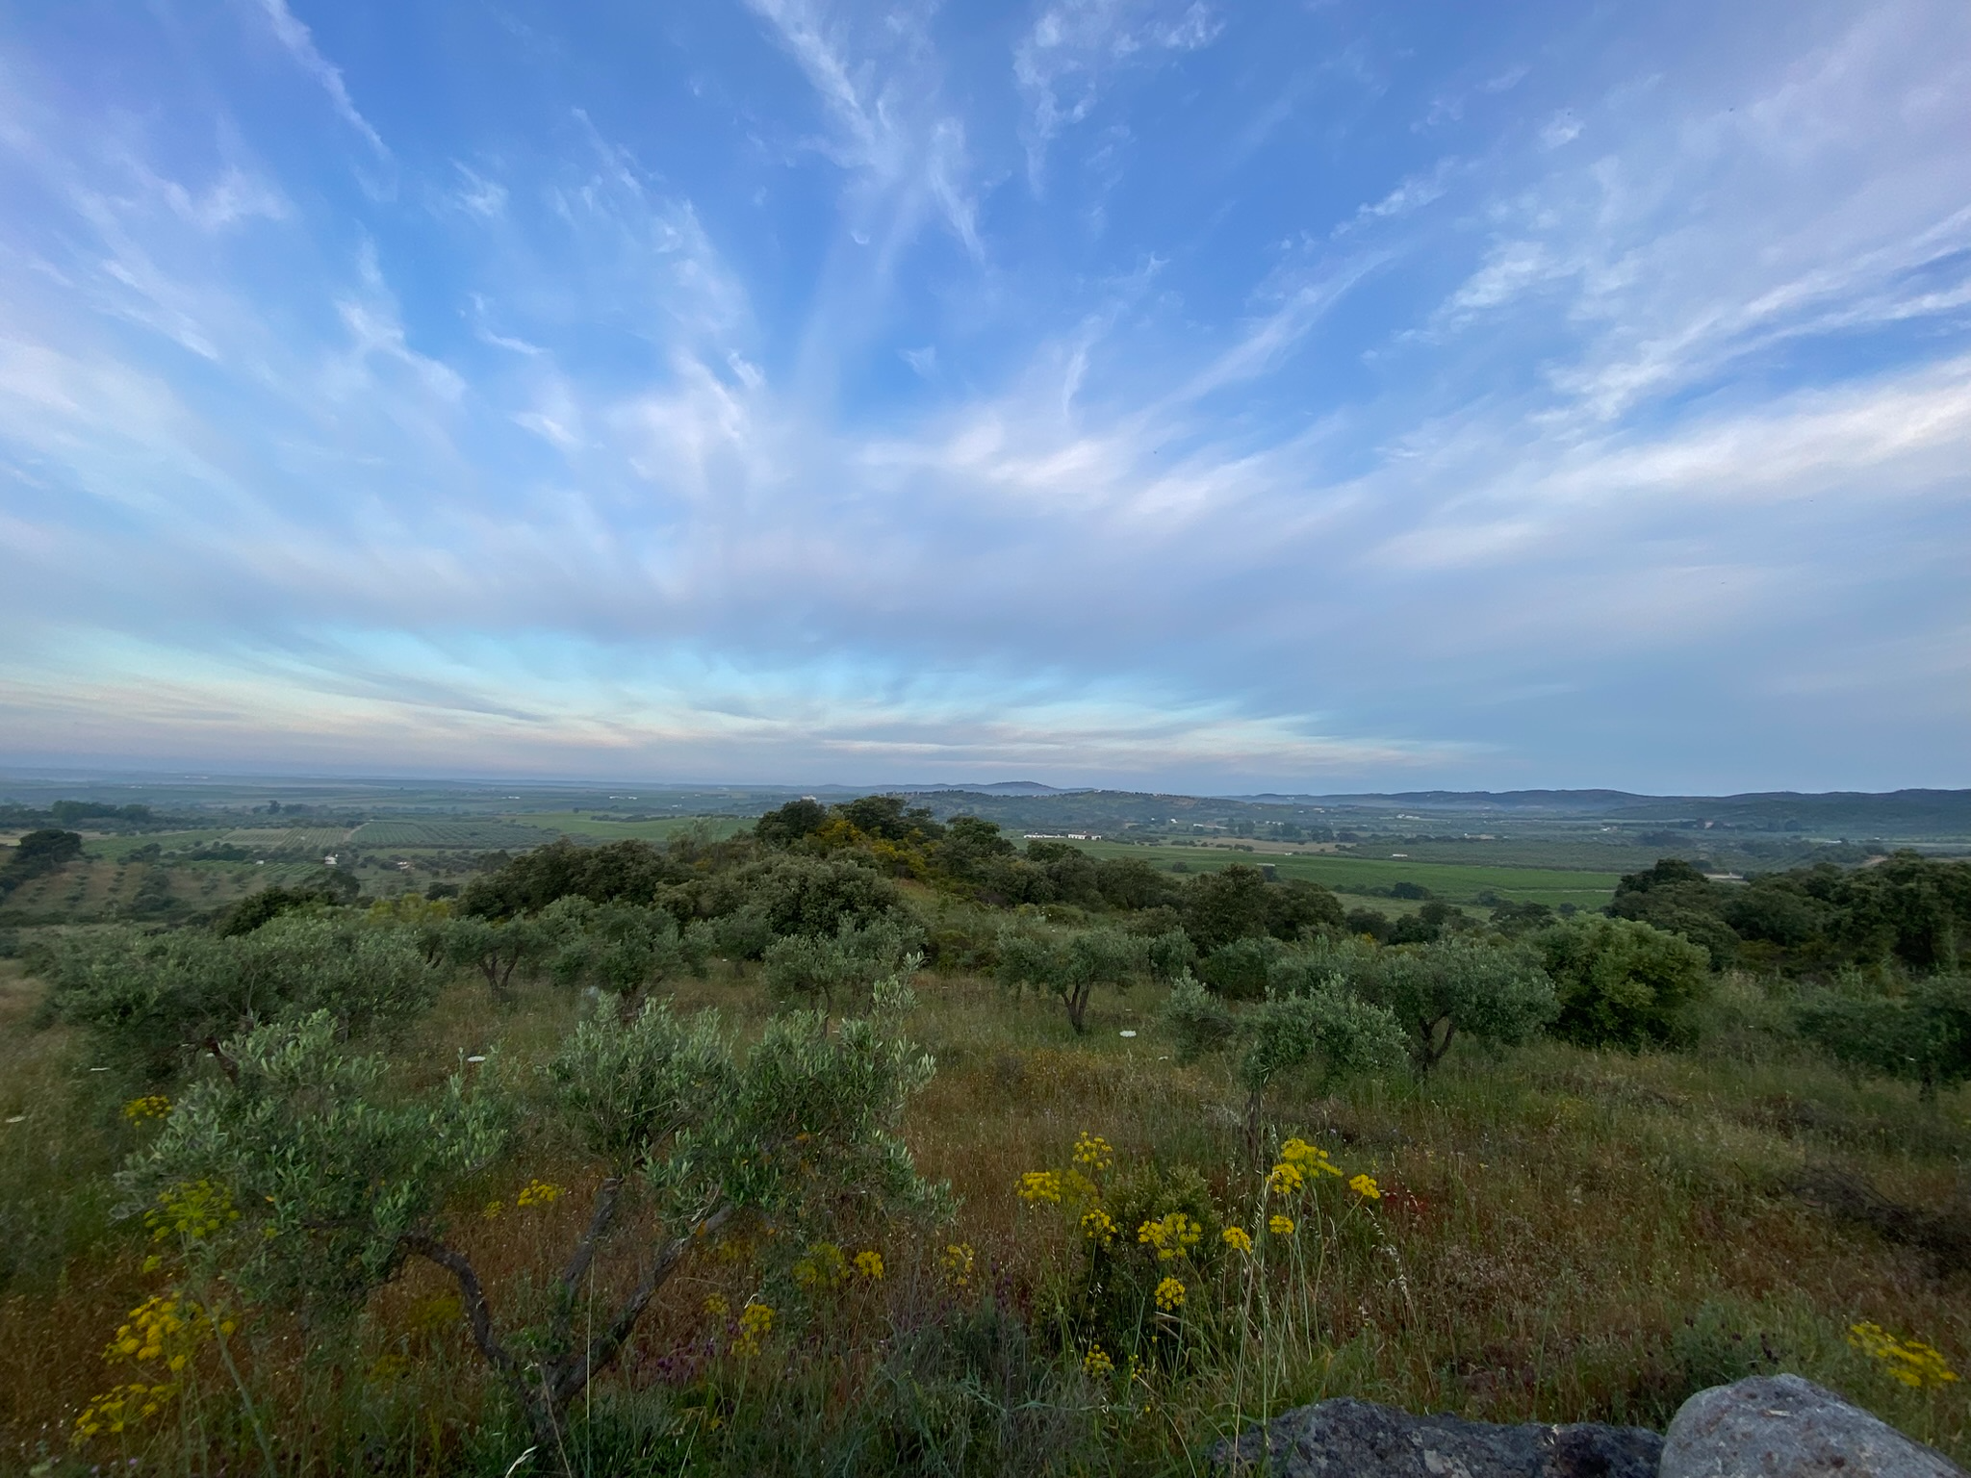

**55555. Tuesday 20th May — Day 15**

**7:30am -- 20 drops Ibotincture:** loving this ibogaine meso dosing protocol.

* ***How will I meet anxiety with breath, movement and a plan I can keep?***
* ***I will choose food and care before urges to numb.***
* ***What one win will make me proud by night?***

**Mesodosing Quotes**

* The road towards sobriety is often long. Ibotincture TA helps me appreciate the beauty in the process.
* As a writer suffering from the apathy of depression, Ibotincture TA has made me rediscover the magic in words again.
* Depression had made me isolate from those I love and pretend I was fine. Ibotincture TA is making me softer, kinder to myself and more honest with others.

Yesterday being my birthday, I could have been kinder to myself.

Coming back to Lisbon, felt the anxiety ramp up — dissociated with afternoon nap and porn instead of trusting **ibogaine’s potential for behavioural addictions** and stress relief.

Anxious about the work I didn’t do and the videos I didn’t film for Transilience.

Anxious because the photo compilation is going to be a tiresome, repetitive task.

Anxious because I feel I haven’t deserved the holidays.

Anxious because I have to succeed at not drinking out of conscious choice from now on.

Just did 45 min of 4-7-8 breathing, then a 1-hour morning meditation as part of **ibogaine micro-dosing for addiction recovery** rather than relying only on willpower.

Now going to have nice hot shower and sit down to start work. Feeling slightly more relaxed.

**Intention:** Regulate through movement, breath, and short breaks today.

**Evening Reflection**

Made it without drinking today. Regulated with the above methods. Today was challenging and full of anxiety and overwhelm (mostly work-related), but I am proud of how I dealt with it and how **ibogaine meso-dosing for depression and anxiety** is slowly changing my responses.

Cooked myself a tasty meal instead of following the impulse to drink alcohol simply because I was actually starving.

**66666. Wednesday 21st May — Mesodosing Day 16**

**7:20am -- 20 drops Ibotincture**

* I will protect my voice and pace in the work, even when speed is tempting.
* How will I dress my body with pride and let confidence lead?
* What story about productivity can I release before bed?

To not succumb to the learned instinct of sweeping the beauty of our own thoughts and emotions under the rug of distraction is to bravely dive for pearls — and while we may only return with grains of sand at times, they will be unapologetically ours.

***On My Fears Around Work and Boundaries***

I suppose a lot of the angst around the work I do in setting up [Ibogenics](https://ibogenics.com/) and [Mesodose](https://mesodose.com/) is the absence of any measurable results or instant gratification (which speaks directly to my need for external validation upon which to judge my self-worth.)

By contrast, my time as a psychedelic integration counsellor at Tabula Rasa Retreat also fed that need, delivering instant gratification, evident in client progress throughout each week.

When it comes to my new admin-heavy task list, I feel I’m falling behind. My admiration for Alvaro is immense, as he has a very organized and speedy work rhythm when it comes to multi-tasking, which I lack.

I also lack the speed. With my current insecurity, and my over-reliance on AI to churn out content, I no longer even see myself as a writer, but someone who feeds prompts into ChatGPT, betraying my own voice and the pleasure I used to get finding the words, polishing the prose.

**Evening Reflection**

Getting ready to turn in for the night.

**What did today feel like?**

Not terribly productive on my behalf, but I was surprisingly okay with that.

I noticed why I chose to drink today. The craving arose because I was starving. I decided to have only a couple of beers at the café around the corner, and then made myself dinner.

**77777. Thursday 22nd May — Mesodosing Day 17**

**6:40am -- 30 drops Ibotincture**

* I will claim agency in small acts and let slowness be sacred.
* How will I widen my menu of relief so alcohol is not the default?
* What would support my body if it could ask in plain words?

I have my own feelings, thoughts, needs & desires & perceptions whether I like it or not. It is as important to develop a strong sense of self as it is to be able to transcend self-hood.

***88888. Two-Week Wrap-Up: What I’ve Succeeded In***

**Reclaiming Agency**  
In this **ibogaine meso-dosing journey**, I’ve started responding to life instead of reacting to it. Small acts like going to bed early, food without shame, journaling instead of numbing, breathwork, self-care are small reclamations of my power.

**Rewiring Self-Soothing Patterns**

* Awareness of my urges (to drink, to avoid pain, to dissociate) have grown gentler and more curious.
* I am making choices more often from presence than compulsion.

**Returning to Creative Flow**

* Things like reading, journaling and, last week’s short holiday at Tabula Rasa
* The active desire to return to my novel
* My enchantment with nature
* My meditative river walks up in Lisbon…all these are proof of reconnection to my authentic self

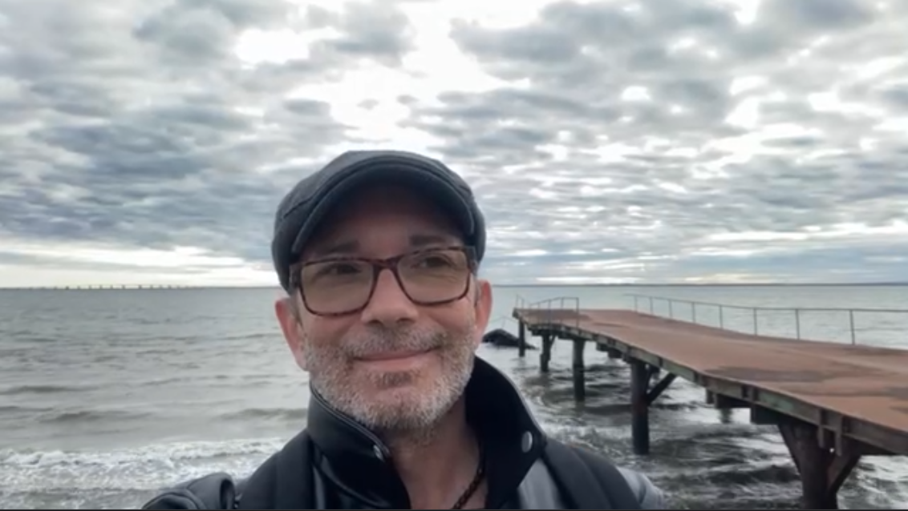

**Rebuilding a Relationship with My Body**

* Taking active care of my psoriasis
* More able to stand naked in front of the mirror and accept every part of my blemished skin

**Cultivating Reverence for Slowness**

* Gone from guilt-ridden output addiction
* Valuing silent sunrises, stillness, and rest with less shame.
* Learning to see my value outside productivity.

***Room for Improvement***

* To trust I don’t need to earn rest.
* To soften the grip of comparison.
* To hold my pain without needing to fix it.
* To acknowledge and work with my ADHD.
* To keep stating and upholding my boundaries and respecting those of others

**Evening Reflection**

Perhaps on account of the 30-drop booster today, I worked fluidly and consciously for 6 hours straight.

When I realized I had skipped lunch, I made myself a quick and simple meal and ate between meetings.

After work, I chose to drink.

Why?   
  
Not because I felt particularly bad, but rather, because the day was a success. I can now hear the inner voice: “If I produce, I earn relief, and relief comes with alcohol.”

I realize that the work ahead may not be to entirely forbid alcohol forever but to widen the menu of relief until alcohol is only one possible item, but not the default dish.

**Questions**

1. **What emotion was I most aware of in the hour before I decided to drink?**

* *Soft anxiety:* capable, clear-headed, organized, prepared.
* *Medium contentment:* confident, fulfilled, proud.

1. **What did I really need in that moment? What could I try next time?**

* Rather than a walk, perhaps relief through music. Something body based to move away from screens and mind.

1. **What would my body have asked for if it could speak directly?**

* Drumming or dancing.

1. **What can I offer myself tomorrow that doesn’t involve alcohol but does involve joy or care?**

* Tomorrow I can either dance at home, or play practice pads, but I won’t have access to the studio drums until Sunday.